Draw E-R Diagram for Hospital Management System.

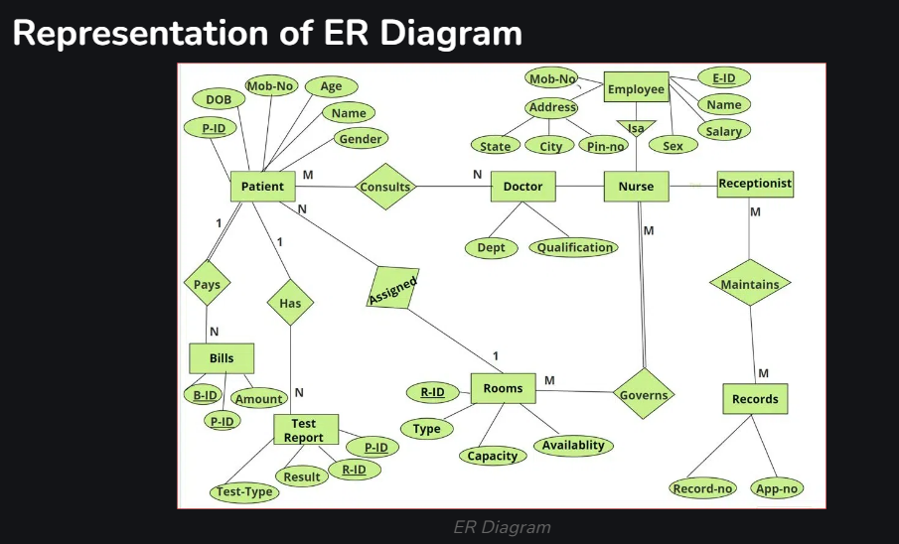

Draw E-R for the online Shopping of food

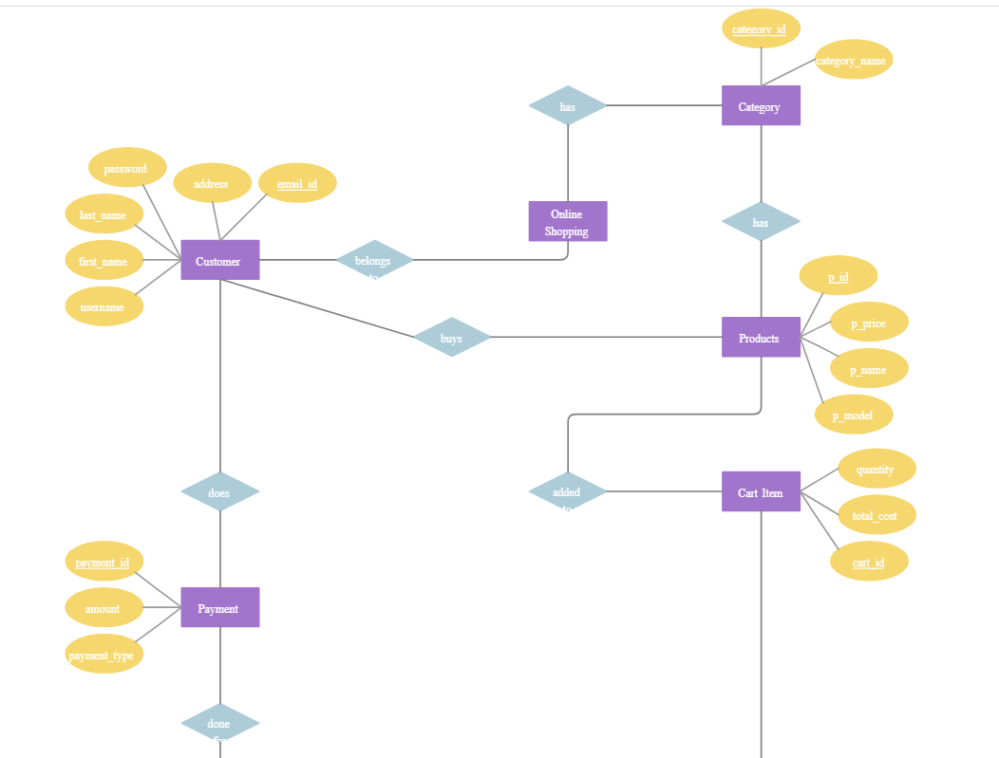

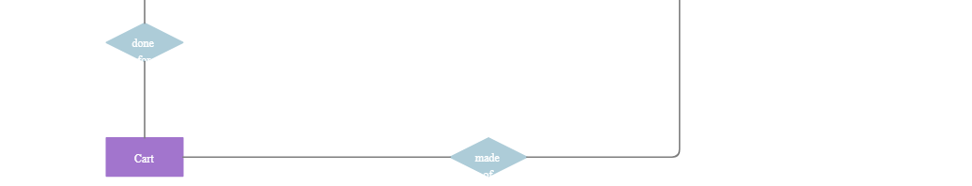

Draw class Diagram for Hospital Management System.

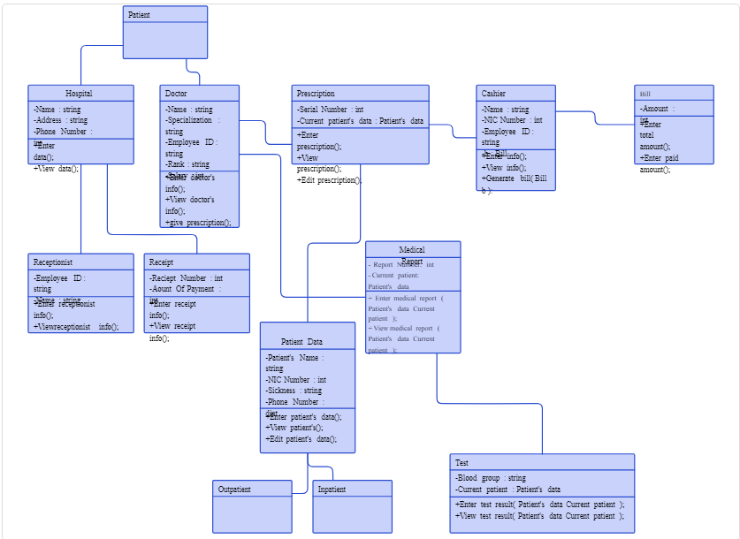

Draw Use Case for Online shopping system.

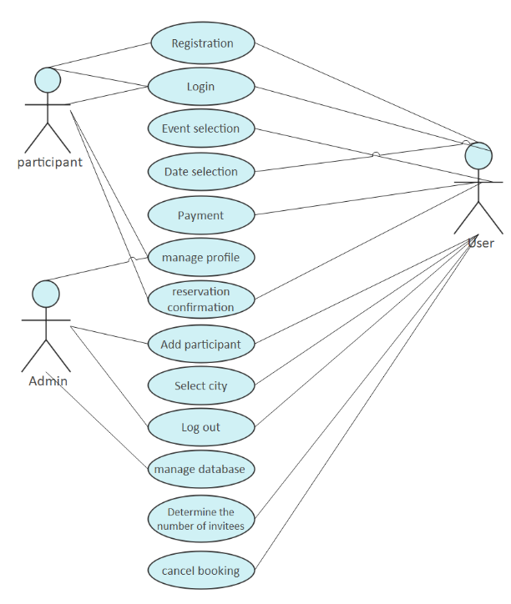

Write down System Concept Statement for Yoga App.

Ans:

**System Concept Statement for Yoga App**

**System Name:** YogaZen – Your Wellness Companion

**Purpose:**  
YogaZen is a mobile application designed to help users improve their physical health, mental well-being, and mindfulness through guided yoga sessions. It offers personalized routines, meditation exercises, and wellness tips to support users in achieving their fitness and relaxation goals.

**Key Features:**

* **Personalized Yoga Plans:** Tailored sessions based on user preferences, fitness levels, and goals.
* **Video and Audio Guidance:** Step-by-step instructions by certified yoga instructors.
* **Progress Tracking:** Logs user activity, session duration, and milestones.
* **Reminders and Notifications:** Customizable practice reminders to promote consistency.
* **Mindfulness and Meditation:** Breathing exercises and guided meditation for stress relief.
* **Health Tips:** Daily wellness tips, posture corrections, and motivation quotes.

**Target Users:**

* Yoga practitioners of all levels (beginners, intermediate, advanced).
* Individuals seeking stress relief, flexibility, or fitness improvement.
* Health-conscious users aiming for consistent wellness routines.

**Benefits:**

* Enhances flexibility, strength, and balance.
* Promotes relaxation and reduces stress.
* Offers convenience with on-demand yoga sessions.
* Encourages consistency through reminders and progress tracking.

**Technology Stack:**

* **Platform:** iOS and Android.
* **Backend:** Cloud-based storage for user data and progress.
* **Frontend:** User-friendly interface with interactive features.
* **Integration:** Compatibility with wearable devices for activity tracking.